OT8 Major Prophets: Isaiah, Jeremiah/Lamentations (emphasis on Isaiah)
Dr. Marvin J. Effa
Isaiah
Author: Isaiah wrote all of Isaiah. The New Testament attributes both sections of Isaiah to Isaiah (Jn. 12:37-41 quotes Isa. 6:9-10 and Isa. 53:1). Furthermore, the argument of Isaiah fails if it is not a single author.
Date of writing: 740–680 B.C. 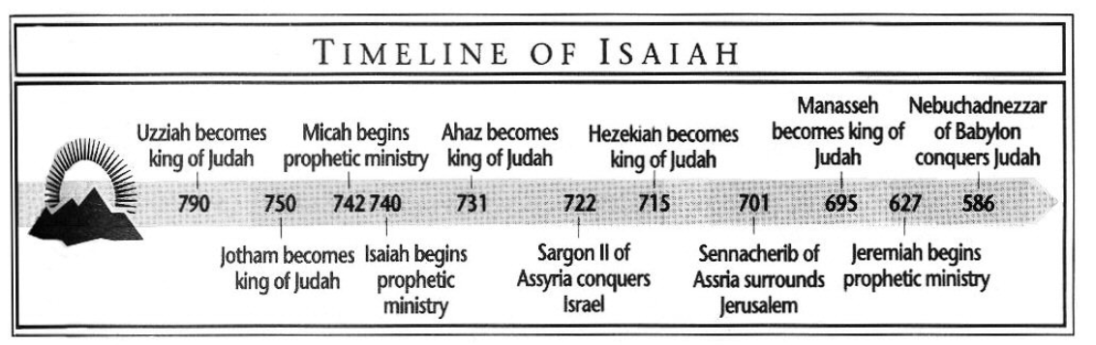
Purpose: To prove that no idol can bring people and nations to judgment, provide salvation, and predict the future.
Idea: The judgment and punishment of God upon sin makes the Messiah’s salvation of Israel and the believer all the more glorious.
Development:
- Prophecies of Judgment and Restoration (Salvation) 1:1-35:10
  - The Overview and Book of Immanuel (chaps. 1–12).
  - The Book of Judgment of Nations (chaps. 13–27).
  - The Book of Judgment of Israel (chaps. 34–35).

Historical Transition from Assyria to Babylon (chaps. 36-39).

- Prophecies of Restoration (Salvation) 40:1-66:24
  - The Book of Cyrus (chaps. 40–48).
  - The Book of the Suffering Servant (chaps. 49–57).
  - The Book of Future Glory (chaps. 58–66).

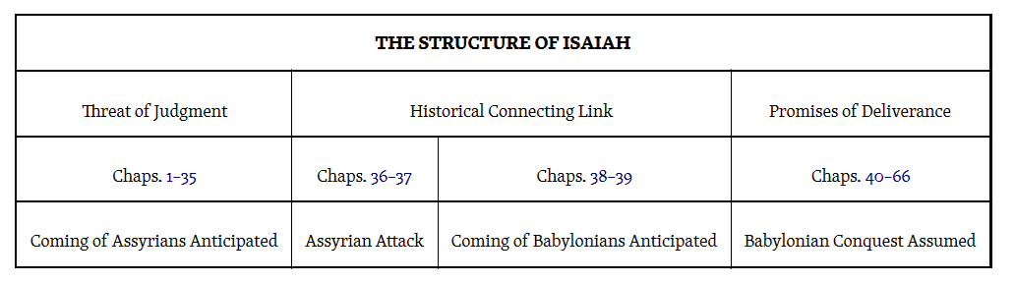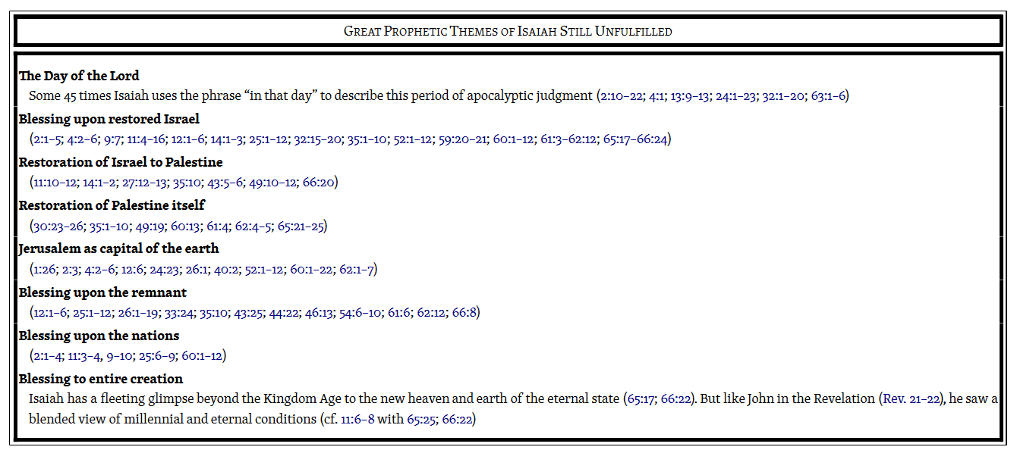

Key Passage Exegesis
- An invitation to consider, Isaiah 1:18.
- A vision of the Lord’s holiness, Isaiah 6.
- The virgin birth, Isaiah 7:14.
- Standard for evaluating preachers, Isaiah 8:20.
- The Child’s coming kingdom, Isaiah 9:1-7.
- The son of Jesse’s kingdom, Isaiah 11:1-16.
- Judgement of the King of Babylon, Isaiah 14.
- Isaiah’s apocalypse, Isaiah 24-27.
- Armageddon and the Kingdom, Isaiah 34-35.
- Waiting for the Lord, Isaiah 40:27-31.
- Cyrus will rebuild the city and the temple, Isaiah 44:28.
- The suffering and triumph of the Servant, Isaiah 52:13-53.
- The Gospel according to Isaiah, Isaiah 55:1-13.
- Kingdom rebuilding of the earth and the scary place, Isaiah 66:22-24.

Israel will NOT escape (1-6), but Immanuel’s remnant will escape, (7-12); the nations will NOT escape (13-39). Idols CANNOT save (40-48), but the Marvelous Servant can, (49-57); so make your choice today (58-66).
Jeremiah
Author: Jeremiah, Jeremiah 1:1. Jeremiah was a priest before he was a prophet. Jeremiah grew up in the priestly village of Anathoth, about three miles north of Jerusalem. Perhaps a childhood in this rural area accounts for the numerous agricultural metaphors which Jeremiah used during his ministry.
Date of writing: 627-585 BC
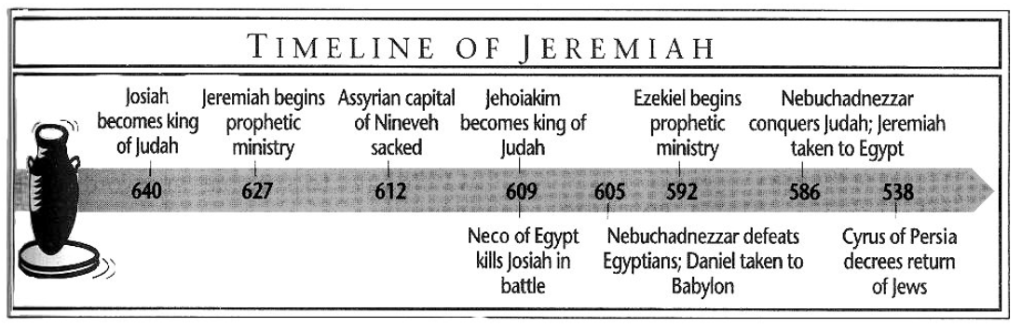
Purpose: To provide an overview of Jeremiah’s prophetic ministry. The logical and/or literary arrangement is unknown at the present. General themes are identifiable: sin, judgement, restoration.
Idea: Each of the sermons and revelations has its own idea (cf. Psalms).
Development: The book is not chronological; it is a combination of topical, biographical, and prophetic material that represents a lifetime of Jeremiah’s ministry.
- Introduction: The Call and Commission of Jeremiah, Jeremiah 1.
- Judgment against Judah and Jerusalem, Jeremiah 2-45.
  - Messages indicting the People, Jeremiah 2-20.
  - Messages announcing the Captivity, Jeremiah 21-39.
  - Messages to the Remnant after the Captivity, Jeremiah 40-45.
- Judgment against the Nations, Jeremiah 46-51.
- Appendix, Jeremiah 52.

Key Passage Exegesis
- Jehoiachin curse, an argument for the virgin birth, Jeremiah 22:30.
- 70 year captivity, Jeremiah 25:11.
- The New Covenant, Jeremiah 31:27-40.
- Prophecies concerning Babylon, Jeremiah 50-51.

Lamentations
Author: Jeremiah, but not stated in the book. Tradition from the third century BC attributes the book to Jeremiah who observed the destruction of Jerusalem and was left behind after the last groups of captives were removed.
Date of writing: The Babylonian siege was from 588 to 586. Babylon had already defeated other nations who may have helped Judah. Wholesale slaughter and destruction accompanied Jerusalem’s fall. Jeremiah was regarded as an enemy to Judah for his pro-Babylon message and was left behind when Babylon established a puppet governor. Jeremiah had first-hand knowledge of the carnage of this avoidable war.
Purpose: To lead people through the public and private expression of grief over devastating, avoidable catastrophe.
Idea: Appropriate lamentation is a prerequisite for restoration (Lamentations 5:21).

Development: The book consists of five poems, one for each chapter, the first four being written as acrostics (each verse begins with a word whose first letter is successively one of the 22 letters of the Hebrew alphabet—except in chap. 3, where three verses are allotted to each letter). These four chapters are also written in what is called “limping meter,” a cadence used in funeral dirges, and thus most appropriate for this lament over the destruction of Jerusalem.
- A Widowed City (chap. 1).
- A Broken People (chap. 2).
- A Suffering Prophet (chap. 3).
- A Ruined Kingdom (chap. 4).
- A Penitent Nation (chap. 5).

Key Passage Exegesis
- God’s faithfulness in tribulation, Lamentations 3:22-24.
- Restoration is always possible, Lamentations 5:21.

G. Michael Cocoris, 2016 Euclid #20, Santa Monica, CA 90405, The Bible: Book by Book, 2000, internet paper.
Smith, J. E. (1992). The Major Prophets (Je). Joplin, MO: College Press.
G. Michael Cocoris, 2016 Euclid #20, Santa Monica, CA 90405, The Bible: Book by Book, 2000, internet paper.
Ryrie, C. C. (1995). Ryrie study Bible: New American Standard Bible, 1995 update (Expanded ed., p. 1249). Chicago: Moody Press.
Smith, J. E. (1992). The Major Prophets (La). Joplin, MO: College Press.

